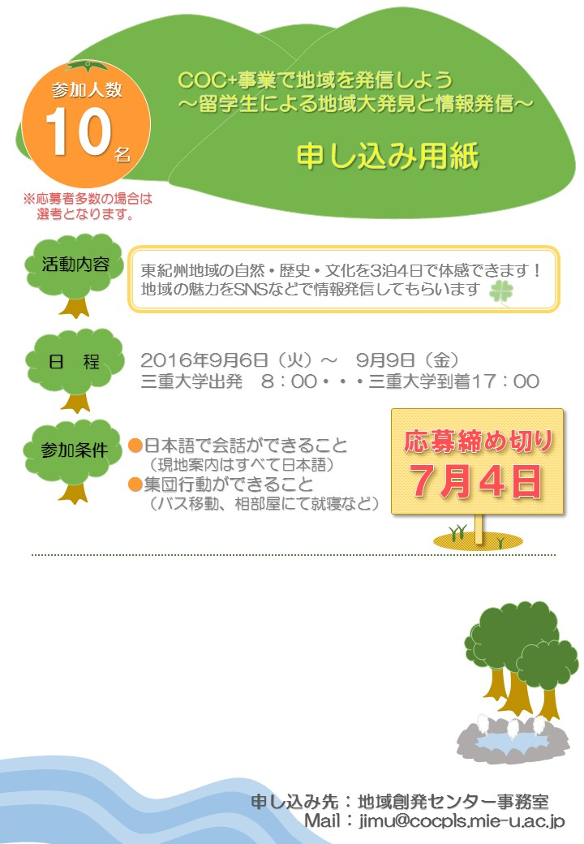

|  |  |  |  |
| --- | --- | --- | --- |
| **ふりがな** |  | | |
| **名　前** |  | | |
| **生年月日** |  | 年　齢 | 歳 |
| **国　籍** |  | | |
| **学　部** |  | 学籍番号 |  |
| **T E L** |  | | |
| **MAIL** |  | | |